Bingo fun for Social Distancing Realness

Spring break 2020 will undoubtedly be one we won’t soon forget. The world has dramatically changed. At the same time, many of us have come together to understand our role and duty in this constantly evolving situation. The need for social and physical distancing has left many students and families trying to come up with inventive and creative ways to pass the time while staying at home.
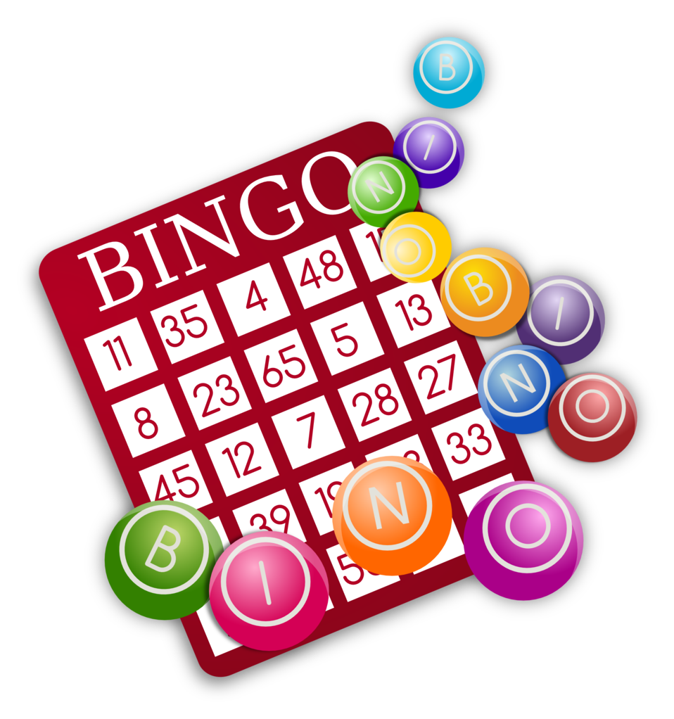
It is for this reason that both Kindra and I came up with a Bingo worksheet for students and families to download and complete while working on their language skills at the same time. It seemed logical to us that we could use this popular classic game and infuse some social responsibility and innovative ideas to get students engaged with their language learning while they remain at home.

My French 9 students always learn the basic fundamentals of the French past tense around this time. Every year, they always tell me “le passé composé is so easy, Monsieur!” Then they go away for spring break and come back all suffering from educational memory loss!?! What’s a teacher to do?! This year, I intend to thwart this annoying syndrome with this simple activity.

To ensure your students practice what they have learned and have fun while doing it, have your students monitor their spring break activities with this activity worksheet. The concept is quite simple. Students colour in the boxes for each activity they complete while on break and ask their parents to initial each box. They can write other activities they did in the target language on the back of the sheet as an added challenge. Then, when you work with your students next, have them report out. Feel free to give a reward for all students who managed to get a Bingo. For added flare, let students know you want to see a X Bingo in order to win a reward (two diagonal lines), or a two-line Bingo in any direction. For the super keeners, strive for a full Blackout Bingo where every square is coloured in. The possibilities are endless!

This worksheet is easily modified to suit your target language. Download a free modifiable version from www.bcatml.org under the Free Resources tab. We would love to hear how you used this simple activity with your students! Please email us at rlavrenc@sd40.bc.ca or kharte@telus.net. Enjoy and may you and your loved ones remain safe during these unprecedented times.

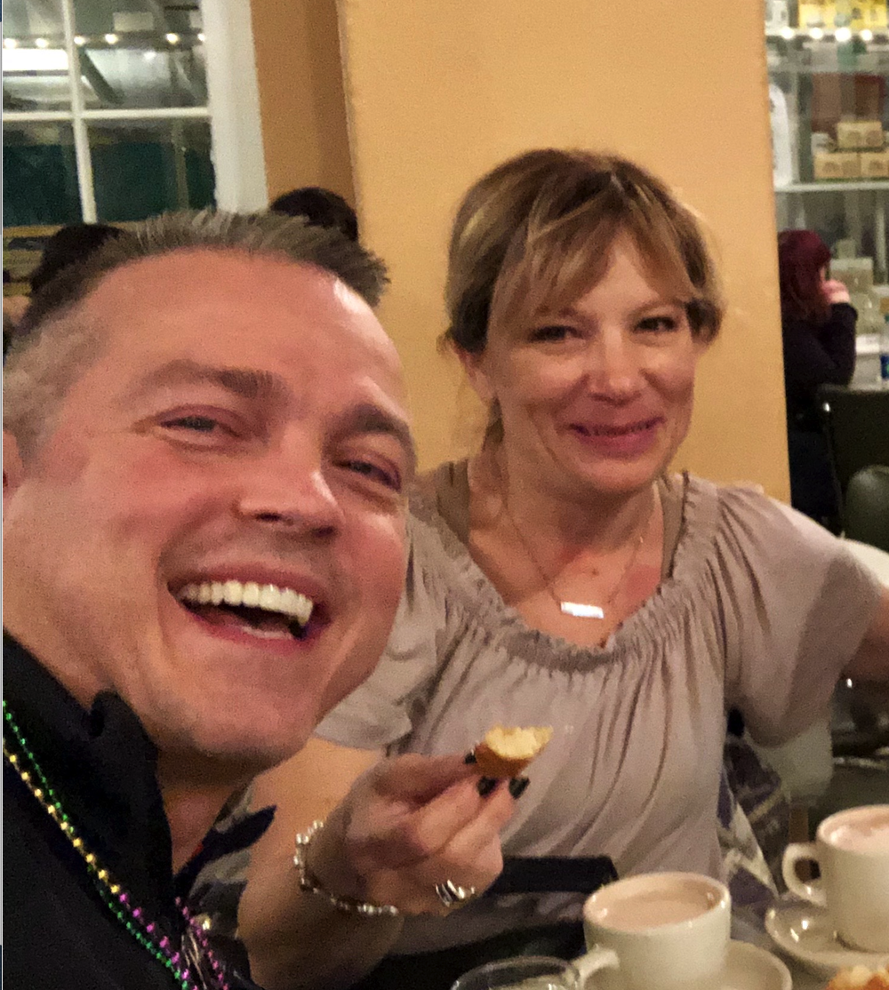

Rome & Kindra
Prénom: _______________

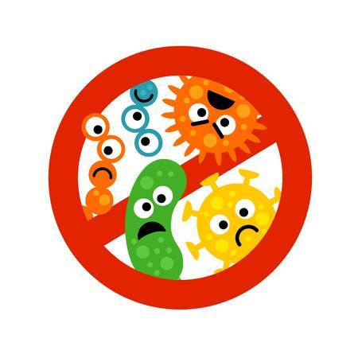
Si tu as fait les activités ci-dessous, colorie chaque case pour voir si tu as fait un bingo. Demande à tes parents de signer chaque case que tu as complétée !
COVID BINGO
J’ai regardé toute une saison d’une série au Netflix/Crave | J’ai lu un roman au complet  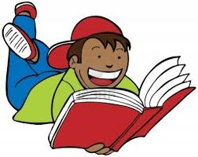 | 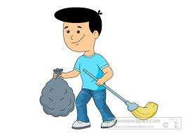  J’ai aidé mes parents avec les tâches ménagères | J’ai complété un casse-tête avec ma famille  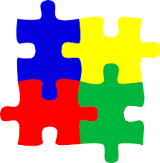 | J’ai suivi un régime sain pendant la période de distanciation sociale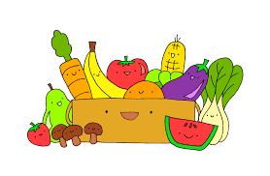
J’ai promené mon chien autour de mon quartier  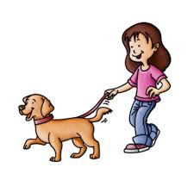 | J’ai enseigné cinq mots de vocabulaire de français à ma famille  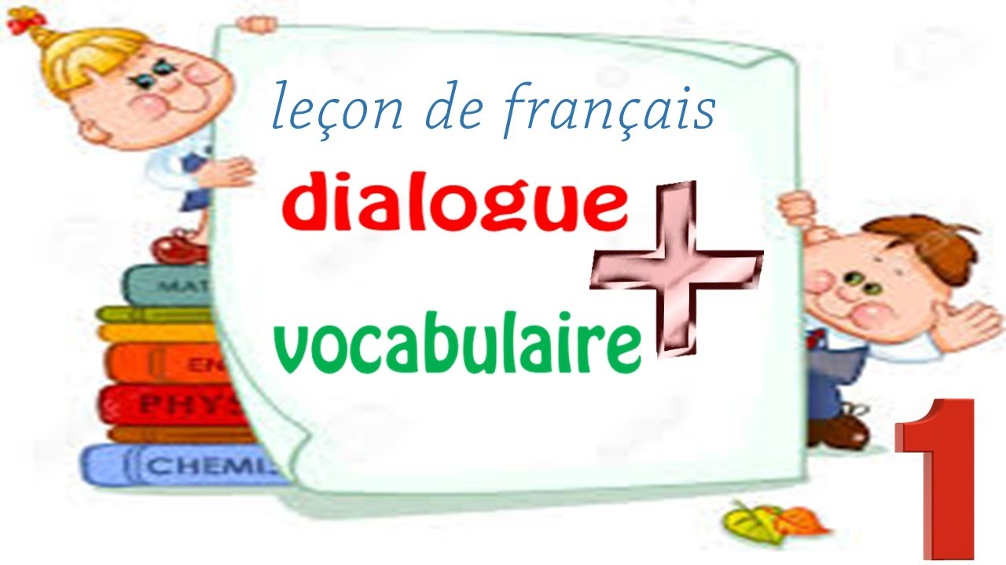 | Je me suis baladé(e) dans le quartier avec ma famille  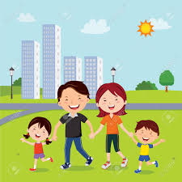 | J’ai joué à un jeu de société avec ma famille  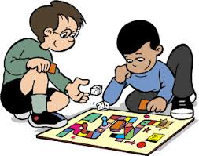 | J’ai rangé ma chambre à coucher  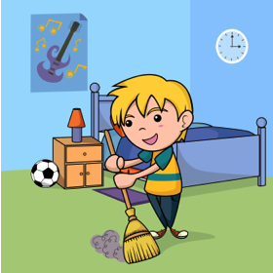
J’ai commencé un nouvel art  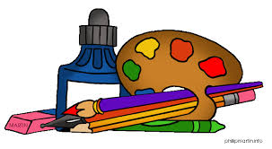 | J’ai fait jouer un vieil album de musique | Je me suis lavé les mains cinq fois aujourd’hui  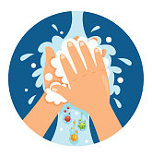 | J’ai fini un devoir/projet pour l’école  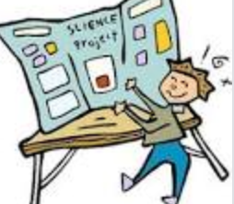 | J’ai téléphoné à mes grands-parents pour voir comment ils vont  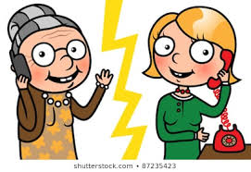
Je n’ai pas utilisé les réseaux sociaux aujourd’hui | J’ai fait un tour virtuel d’un musée célèbre  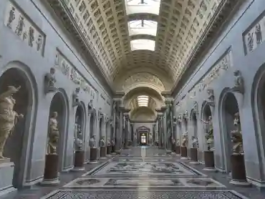 | J’ai essayé une nouvelle recette dans la cuisine | J’ai fait des projets pour cet été avec ma famille  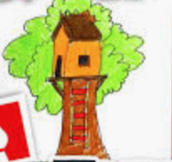 | J’ai parlé en français virtuellement avec un(e) ami(e) de classe  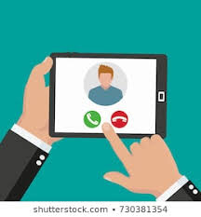
J’ai écrit dans mon journal intime | J’ai applaudi les premiers soignants au balcon à 19H | J’ai inventé une histoire fictive  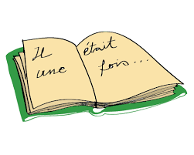 | J’ai écouté de la musique française  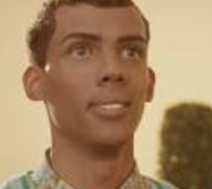 | Je n’ai pas mangé de casse-croûte aujourd’hui  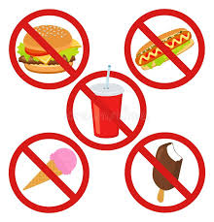

Créé par R. Lavrencic & K. Harte (rlavrenc@sd40.bc.ca | kharte@telus.net)
Name: _______________

Colour in each box for all the activities listed below to see if you won a bingo. Ask your parents to initial each box you have completed.
COVID BINGO
I watched an entire season of a series on Netflix/Crave | I read an entire novel | I helped my parents with some chores | I finished a puzzle with my parents | I ate a healthy diet during the entire social distancing period
I took my dog for walk around the neighbourhood | I taught five new French vocabulary words to my family | I went for a stroll in my neighbourhood with my family | I played a board game with my family | I tidied and cleaned up my bedroom
I started a new arts or craft | I played an old record album | I washed my hands five times today | I finished a project/task for school | I called my grandparents to check up on them
I didn’t use any social media today | I took a virtual tour of a famous museum | I tried a new recipe in the kitchen | I made summer plans with my family | I spoke virtually with a classmate in French
I wrote in my personal diary | I clapped for the first responders at 7:00 pm | I started writing a new story | I listened to some French music | I didn’t eat any junk food today

Created by R. Lavrencic & K. Harte (rlavrenc@sd40.bc.ca | kharte@telus.net)

Nombre: _______________

¿Qué hiciste?
COVID BINGO
Miré una serie completa de un programa de Netflix/Crave. | Leí un libro. | Ayudé a mis padres con los quehaceres. | Hice una rompecabezas con mi familia. | Seguí una rutina buena para mi salud.
Caminé con mi perro. | Enseñé cinco palabras nuevas en español a mi familia.  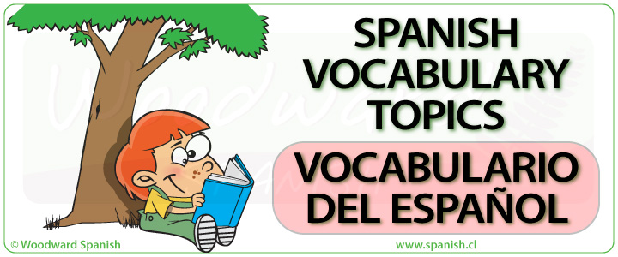 | Salí a caminar con mis padres. | Jugué un juego con mi familia. | Limpié mi cuarto.
Comencé una nueva artesanía. | Escuché música que le gusta a mis padres. | Me lavé las manos cinco veces hoy. | Hice la tarea para la escuela. | Hablé con mis abuelos.
No usé ninguna  red social hoy. | Visité un museo virtual hoy. | Intenté una receta nueva. | Hice unos proyectos con mi familia. | Hablé con una compañera de clase virtualmente.
Escribí un mi diario personal. | Animé a los trabajadores de primera línea. | Escribí un cuento.  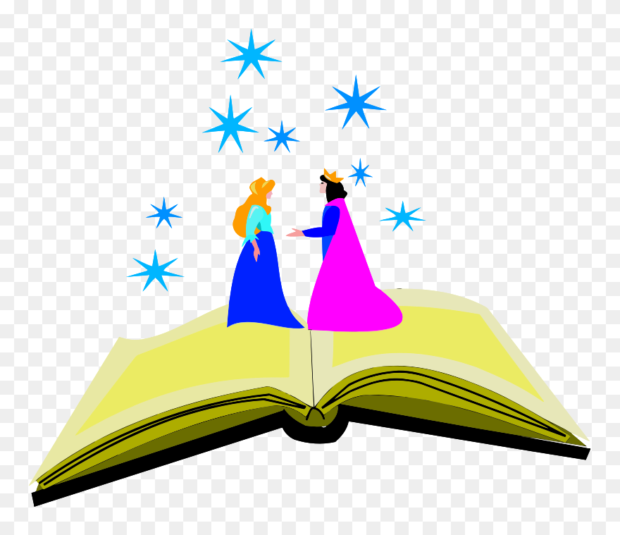 | Escuché la música en español. | Hoy no comí comida chatarra.

Hecho por K. Harte & R. Lavrencic (kharte@telus.net | rlavrenc@sd40.bc.ca)

