BCATML Fall Conference 2014 : Celebrating Languages! Program |  |  |  |  |  | Friday, October 24, 2014, Delta Burnaby Hotel and Conference Centre
 | French | Spanish | Mandarin | Japanese | German |  | Tech | Publishers/ French | General | General
Session A  8:30 – 9:40 | Mastering Verbal Communication & Audio Comprehension in Core French  Nicole Jarvis (P,S) | Getting Started with Teaching Proficiency through Reading and Storytelling : Three Steps to Storytelling in the Second Language Classroom  Michelle Metcalfe (P,S) | A Hero’s Journey  Kai Zhang  (S) | iPad Applications for Japanese Class  Akemi Takizawa (P,S) | Dürer, Porsche, Erzgebirge : Interdisziplinäre Projekte im Deutschunterrict  Wieland Petermann & Ulla In der Stroth (P,S) |  | Practical tips and tricks for the Chinese iPad classroom  Cynthia Xu  (All Easier Corp. – Better Chinese)  (P, S) | The Quebec Question  Polly Dobie (S) | Building Your Class Website- An Introduction to Weebly  Ron Dorland (Tech, G) | Quality Assessment in the Second Language Classroom  Monica Davidson, Barb Huva  (S)
Session B  9:55 - 11:05 | Using Intensive French Methodology in a Core French Classroom  Andrea Dunlop  (P,S) | Getting from Spoken Production to Spoken Interaction  Susan Kabotoff, Lauren Bell (French and Spanish) | Infusing Cultural Understanding and Appreciation into Modern Mandarin  Ping Li (S) | Enjoy! Learning Japanese with the new website “MARUGOTO Plus”  Mami Saito (P,S) | Ideen für die Arbeit mit heterogenen Lerngruppen  Ulrike Kugler  (S) |  | BCATML iPad Inquiry Project Rome Lavrencic, Nancy Griffith-Zahner  (P,S) | The Essential Question: “The Glue that Binds our Lessons”  Elizabeth Sacco (EMC Publishing) (S) | Update on BC Curriculum Transformation  Laura Hawkes & Brent Munro (Min. of Ed.), Claire Guy (SD35)  (G) | 21st Century  Language (Punjabi) classrooms  Amandee Chhina, Gurpreet Bains (P,S)
11:15-12:45 | BCATML | Annual | General | Meeting | & |  | Plated | Service | Lunch | (Ballroom)
Session C  1:00 – 2:10 | Songs, Music Videos, and Internet Activities in the high school French Classroom  Aileen Vildort (S) | Music in All Levels of Spanish, Interactive Workshop  Trevor O’Rourke (P,S) | Technology in the Mandarin Learning Classrooms  Tina Tsai, Erica Huang (P,S) | Curation, Useful Websites, and Web 2.0 tools for Japanese Classes  Stacia Johnson (P,S) | 25 Jahre danach: 1st de Fall de Berliner Mauer noch ein Thema für junge Deutschlerner?  Wieland Petermann & Antje Blume (P,S) |  | Technology Integration in Language Teaching  Marco Hernandez (P,S) | Échos Pro Takes Core French to a New Level  Wendy Carr, Stacey Sveistrup  (P) | Update on BC Curriculum Transformation  Laura Hawkes & Brent Munro (Min. of Ed.), Claire Guy (SD35)  (G) | Movie Talk and Embedded Reading: Enhancing the Comprehensible Input  Adriana Ramirez  (S)
Language Forums  2:20 – 3:00 | French  Nancy Griffith-Zahner | Spanish  Trevor O’Rourke | Mandarin  Ping Li | Japanese  Wendy Yamazaki | German  Angela Kleine-Buning |  | Other Languages  Kelly MacLean | Elementary – Middle Years  Stacia Johnson |  | Punjabi  Nicole Jarvis
Target Audience: (P): K-7 teachers; (S): Secondary teachers; (G): General

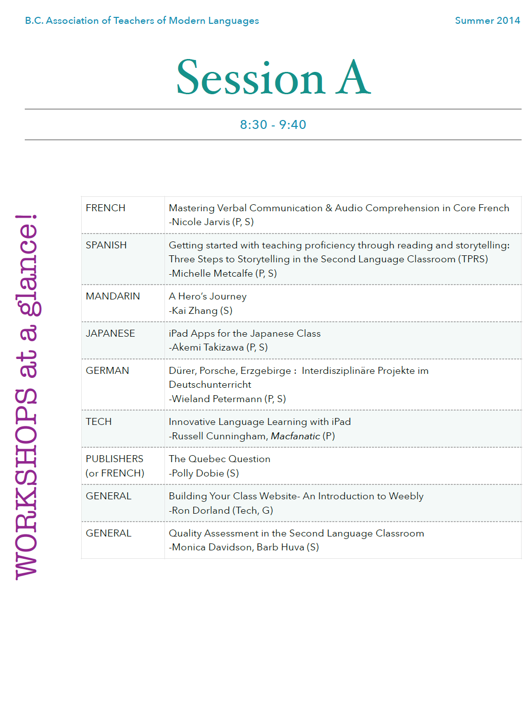
Page11.jpg