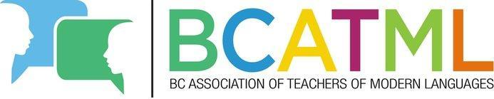
BCATML Teacher Study Grant

Award Information:

To help BCATML members improve their language skills for their own professional development, the British Columbia Association of Teachers of Modern Languages is offering a study grant for BCATML members. The grant provides up to four (4) $500 awards for B.C. teachers who are current members of the BCATML (sitting executive members excluded) who wish to improve their fluency in the language that they currently teach or wish to teach. This grant is not intended for attending professional development workshops or conferences.

Grant Value $500
Deadline: December 30th

After the deadline, all applications meeting the following criteria will be pooled together and four (4) will be randomly chosen in a lottery draw.

Teachers shall receive the BCATML Teacher Study Grant once proof of successful completion (e.g. transcript, certificate of completion, letter of completion from the instructor/institution, etc.) is provided. Funds will be forwarded to you only when official proof of completion of the approved course has been submitted. This must be done (or postmarked) within 2 months of completion of the course.

Application Eligibility Criteria and Requirements:

Priority will be given to applicants who best meet the following criteria with supporting documentation:

- Teachers teaching in a BC school (public or independent), who hold a membership to the BCATML
- Evidence of registration in a Modern Language course or program in a post-secondary or continuing education institution, locally or abroad.

Application:

Please complete all sections of the application.

Successful applicants may be required to provide their SIN in order receive their BCATML Teacher Study Grant as per BCTF Accounting procedures.
Application Form
Full Name of Applicant: | SURNAME, GIVEN NAMES
Date of Birth | ____/____/________  MM/DD/YYYY
Telephone Numbers | (______) ______ - ________ (______) ______ - ________
E-mail Address:
HOME  Mailing Address | UNIT NUMBER, HOUSE NUMBER, STREET NAME
 | CITY/TOWN, POSTAL CODE
Post-secondary Institution: |  | Period Attending:
Citizenship Information | ▢ Canadian Citizen ▢ Permanent Resident (Landed Immigrant)  CHECK ONE
Current school (place of employment)

DECLARATION

I HAVE READ AND UNDERSTOOD THE INSTRUCTIONS, AND DECLARE THAT:
- All information provided is true and complete;
- I am a current BCATML member
- I will immediately notify the British Columbia Association of Teachers of Modern Languages in writing if I withdraw from the language course/program.

________________________________________
Name of Applicant

________________________________________ ____________________
Signature of Applicant Date Signed

SUBMISSION INSTRUCTIONS
Please email the entire application package to psac51@bctf.ca by December 30th .

