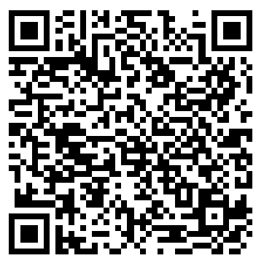
- What do you like about the Core French curriculum draft?

- What revisions do you think need to be made to the Core French curriculum draft?

- What questions do you have about the new curriculum?

- Do you have any additional comments?

(Please continue writing on back if you require more space.)
Please return this form to Laura Hawkes before you leave or e-mail this form to curriculum@gov.bc.ca
In order to help contextualize the information you have provided, it would be helpful for us to know your role in your school/district (please check all that apply or put an X if using a keyboard):

__ Elementary teacher __ Middle years teacher __ Secondary teacher
__ Educational Assistant __ School administrator __ District Language Coordinator
__ Pre-service teacher __ Post-secondary professor __ Other: __________________

